Exercise 1: Control Structures

Scenario 1: The bank wants to apply a discount to loan interest rates for customers above 60 years old.

Question: Write a PL/SQL block that loops through all customers, checks their age, and if they are above 60, apply a 1% discount to their current loan interest rates.

Solution Script:

BEGIN
FOR record IN (
SELECT L.LoanID
FROM Customers C
JOIN Loans L ON C.CustomerID = L.CustomerID
WHERE MONTHS_BETWEEN(SYSDATE, C.DOB) / 12 > 60
FOR UPDATE
) LOOP
UPDATE Loans
SET InterestRate = InterestRate - (InterestRate * 0.01)
WHERE LoanID = record.LoanID;
END LOOP;

COMMIT;

DBMS_OUTPUT.PUT_LINE('1% interest discount applied to customers above 60!');
END;

Output:
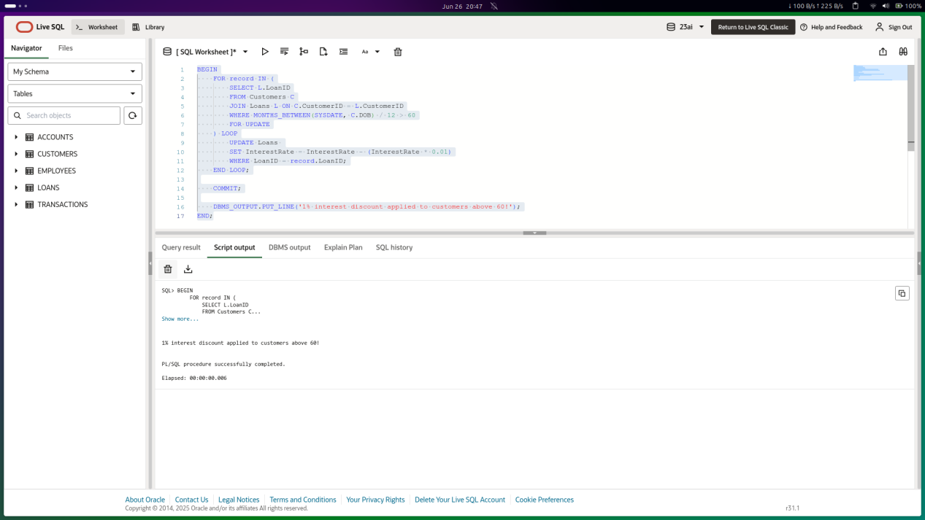
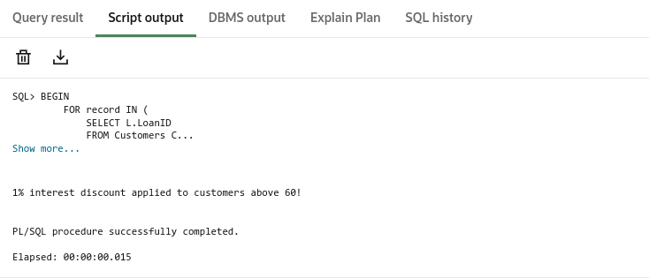

Scenario 2: A customer can be promoted to VIP status based on their balance.

Question: Write a PL/SQL block that iterates through all customers and sets a flag IsVIP to TRUE for those with a balance over $10,000.

SOLUTION SCRIPT

ALTER TABLE CUSTOMERS
ADD ISVIP VARCHAR2(5) DEFAULT 'FALSE';

BEGIN
FOR RES IN (
SELECT CUSTOMERID, BALANCE FROM CUSTOMERS
) LOOP
IF RES.BALANCE > 10000 THEN
UPDATE CUSTOMERS
SET ISVIP = 'TRUE'
WHERE CUSTOMERID = RES.CUSTOMERID;
END IF;
END LOOP;

COMMIT;
END;

OUTPUT
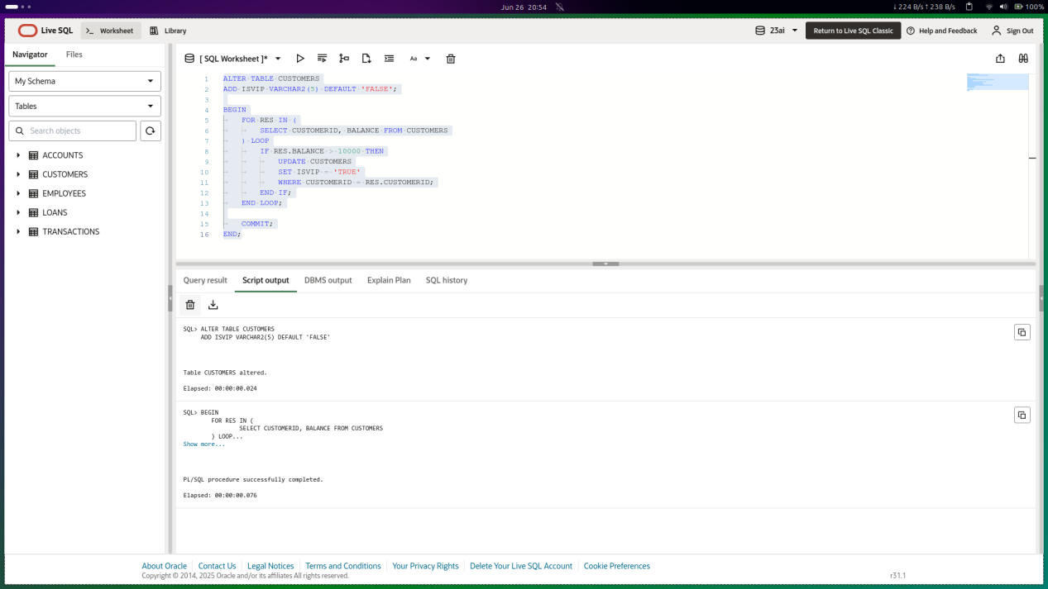
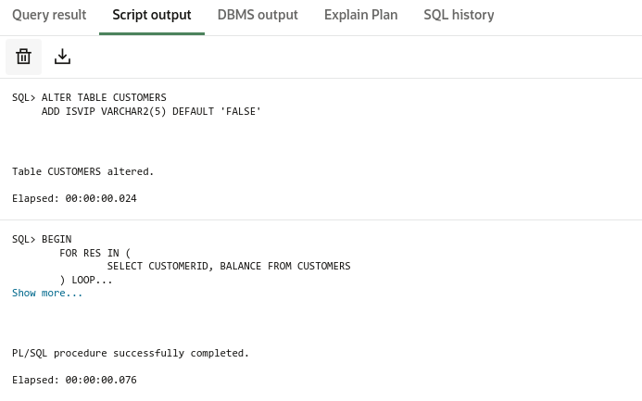

Scenario 3: The bank wants to send reminders to customers whose loans are due within the next 30 days.

Question: Write a PL/SQL block that fetches all loans due in the next 30 days and prints a reminder message for each customer.

SOLUTION SCRIPT

BEGIN
FOR res IN (
SELECT C.NAME, C.CUSTOMERID, L.LOANID, L.ENDDATE
FROM LOANS L
JOIN CUSTOMERS C ON L.CUSTOMERID = C.CUSTOMERID
WHERE L.ENDDATE BETWEEN SYSDATE AND SYSDATE + 30
) LOOP
DBMS_OUTPUT.PUT_LINE(
'Reminder: Customer ' || res.NAME ||
' (ID: ' || res.CUSTOMERID || ') has a loan due on ' ||
TO_CHAR(res.ENDDATE, 'YYYY-MM-DD')
);
END LOOP;
END;
/

OUTPUT
